GRANARD MUNICIPAL DISTRICT

Corporate Affairs,
Aras an Chontae,
LONGFOIRT.

22nd July 2014.

To: Each Member of Granard Municipal District.

Dear Member,

You are requested to attend Meeting of Granard Municipal District to be held in the Granard Community Library, on Tuesday, 29th July 2014 at 4.00 p.m. to transact business, as set out on the Agenda hereunder.

Yours sincerely,
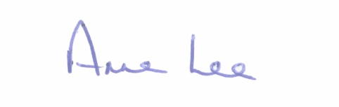

_______________
Anne Lee,
Meetings Administrator.

AGENDA

Prayer before meeting.

1. Confirmation of Minutes of First Annual Meeting of Granard Municipal District held on the 16th June 2014 - copy enclosed.

2. Matters arising from Minutes.

3. Establishment of sub-committee in relation to review of County Development Plan 2009-2015 - Nomination of Members from Granard Municipal District.

4. Consideration of Draft Granard (Parking) Bye-Laws 2014 - Report enclosed.

5. Consideration of the Taking in Charge of “Crann Íur’, Housing Estate, Ennybegs, Co. Longford - Report enclosed.

6. Notices of Motions submitted by Councillors, as listed hereunder -

Councillor P.J. Reilly.

“That a letter be forwarded to Mr. Christy Duffy, C.E.O., Education and Training Board, regarding the closure of Youth Reach in Granard.”

Councillor John Duffy.

“I request the road design team to apply to the National Roads Authority for funding for the erection of a crash/safety barrier on the R198 adjacent to Moyne Community and St. Patrick’s National School. This is a very dangerous section of road for about 100 metres, since the felling of trees along the side of this road.

Councillor Martin Mulleady.

“I ask that funding be requested for a pedestrian crossing, as a matter of urgency on safety grounds, from the Doctor’s Surgery to the Centra Supermarket in Drumlish Village.

Councillor Paraic Brady.

“I request that, in the interest of public safety, that the R194 Road at Killeenatruan Cross, Killoe be realigned and widened.”

7. A.O.B.

